**INTERFACING OF RELAY AND BULB WITH 8051 USING PROTEUS**

**AIM:**

To write an assembly language program to interface Relay and Bulb with 8051 using Proteus.

**SOFTWARE REQUIRED:**

* Proteus 8 software.

**PROGRAM:**

ORG 0000H

UP: SETB P2.0

ACALL DELAY

CLR P2.0

ACALL DELAY

SJMP UP

DELAY: MOV R4,#18

H1: MOV R3,#255

H2: DJNZ R3,H2

DJNZ R4,H1

RET

END

**CIRCUIT DIAGRAM:**

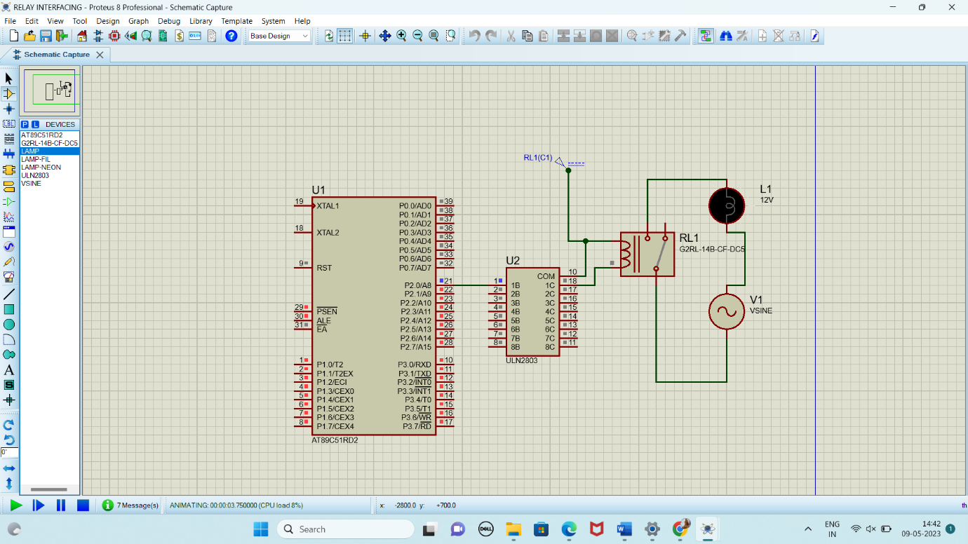

**OUTPUT:**

* The Bulb connected through the relay will glow at regular intervals with a controlled ON and OFF duration.
* The relay acts as a switch controlled by the 8051 microcontroller, turning the bulb ON when P1.0 is HIGH and OFF when P1.0 is LOW.
* The ON/OFF rate of the buzzer can be adjusted by modifying the delay times in the subroutine.

**RESULT:**

Thus, the program has been successfully verified and executed.